Windows Log Collection using Splunk Enterprise
Date: August 04, 2026

Project Overview
In this lab, I set up a basic Security Information and Event Management (SIEM) environment using Splunk Enterprise and the Splunk Universal Forwarder.
The goal was to collect Windows logs from a client machine and forward them to a centralized Splunk server for indexing and analysis. This project demonstrates the fundamental process of log collection used in Security Operations Centers (SOCs).

Objectives
- Install Splunk Enterprise
- Install Splunk Universal Forwarder
- Configure Splunk to receive forwarded data
- Connect the Windows endpoint to the Splunk server
- Import and index Windows logs
- Verify successful log collection

Technologies Used
Category | Tool
SIEM | Splunk Enterprise
Log Collection | Splunk Universal Forwarder
Operating System | Windows 10
Protocol | TCP

Implementation
Step 1: Installing Splunk Enterprise
Splunk Enterprise was installed on the Windows system. After the installation completed, the Splunk web interface was launched successfully.
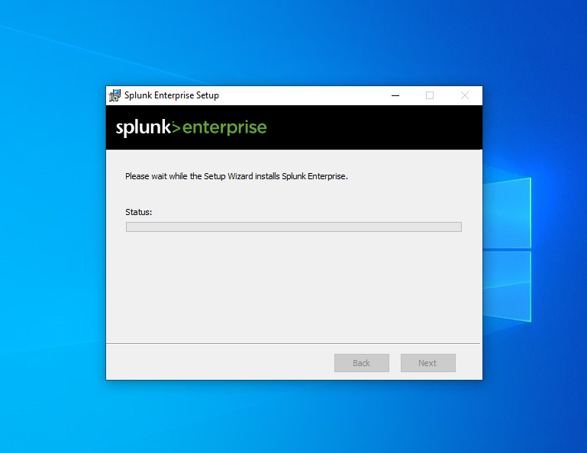
Figure 1: Installation of Splunk enterprise
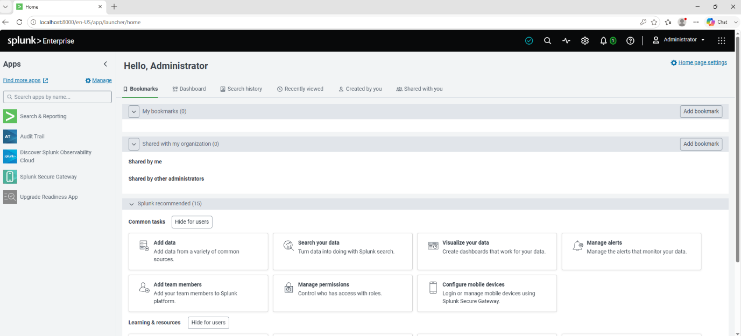
Figure 2: splunk Installed

Step 2: Installing the Universal Forwarder
The Splunk Universal Forwarder was installed on the client machine. During installation, the management server details were provided to enable communication with the Splunk instance.
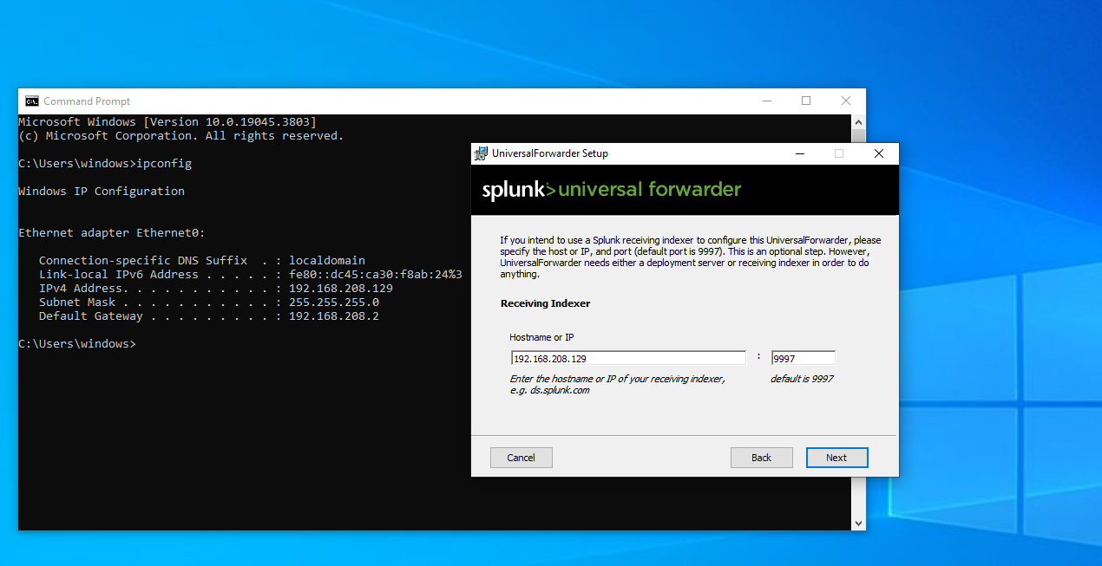
Figure 3: Installation of Universal forwarder

Step 3: Configuring Data Receiving
The receiving port was configured on Splunk Enterprise to allow incoming connections from forwarders.
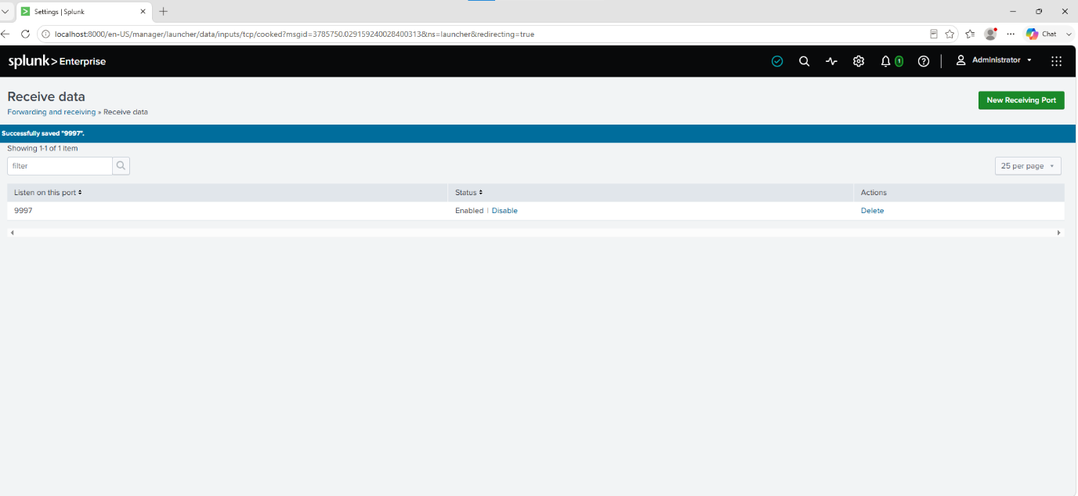
Figure 4: Configuring the receiving port

Step 4: Verifying Forwarder Connection
After configuration, the Universal Forwarder successfully appeared in the Splunk Forwarder Management page, confirming communication between the endpoint and the server.
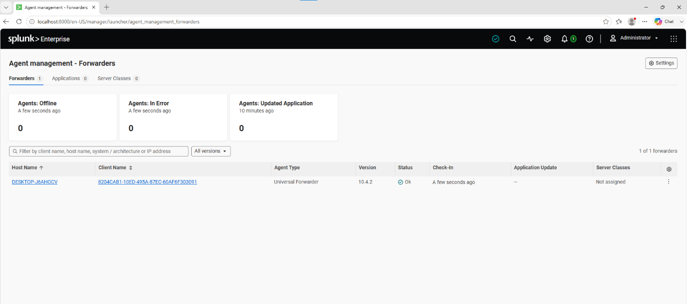
Figure 5: Agent connected with splunk

Step 5: Importing Data
Using the Add Data wizard, the connected forwarder was selected as the source for collecting Windows log data.
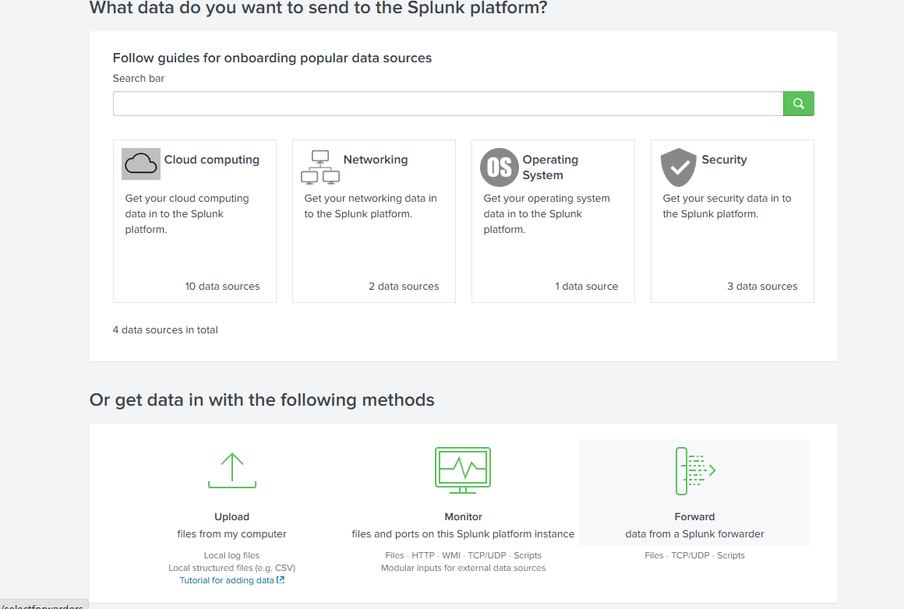
Figure 6: Importing logs using forwarder
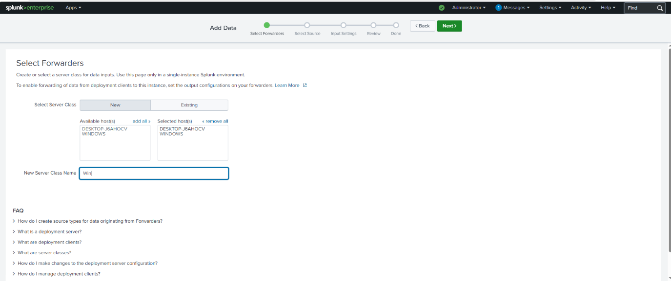
Figure 7: select Forwarder

Step 6: Configuring Data Input
The input type, source type, and destination index were configured before starting log collection.
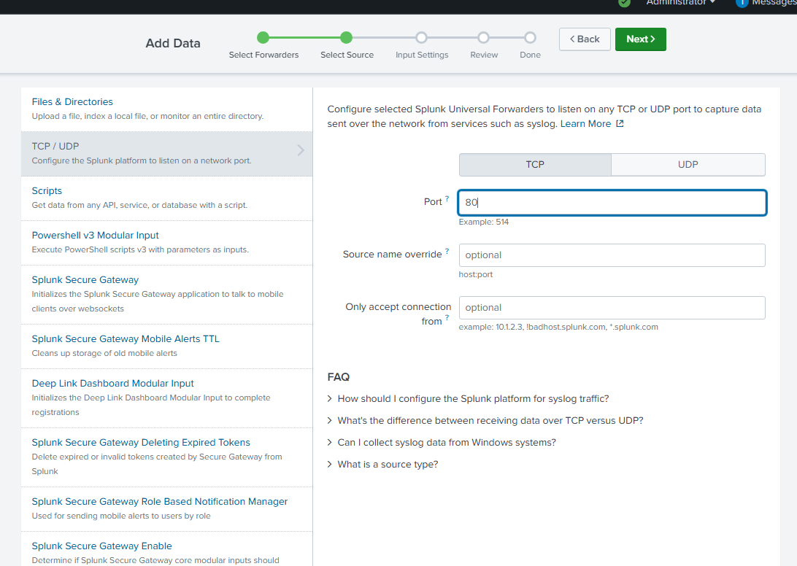
Figure 8: Selecting the type of Data to import
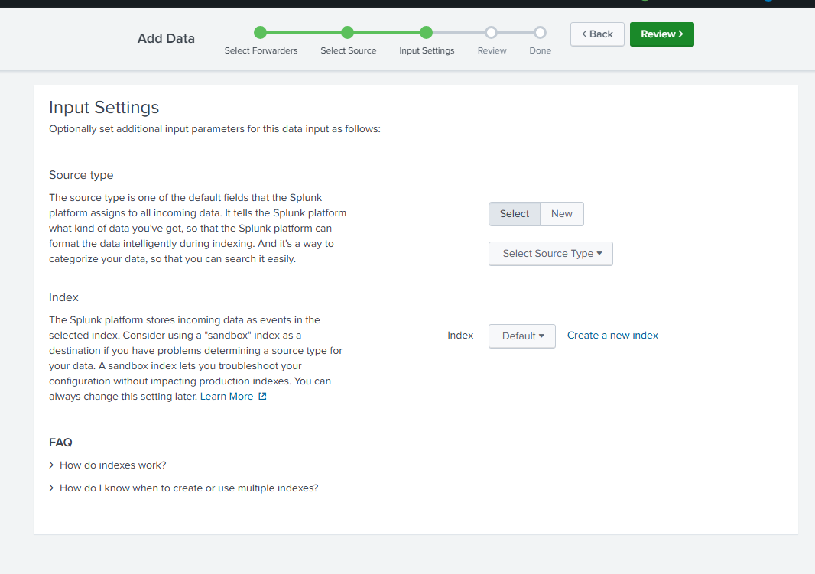
Figure 9: Defining Source type and index

Step 7: Reviewing the Configuration
All settings were reviewed before submitting the configuration to begin indexing logs.
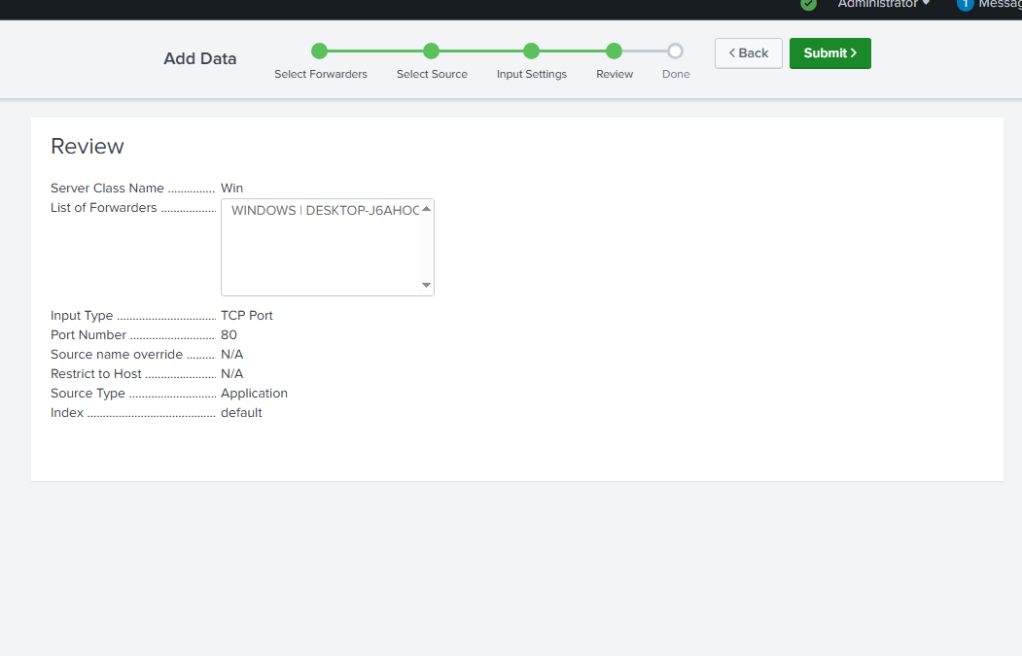
Figure 10: Review and Submit

Results
The Splunk Universal Forwarder successfully established communication with the Splunk Enterprise server. Windows log data was forwarded, indexed, and made available for searching through the Splunk interface.

Skills Demonstrated
- SIEM deployment
- Splunk Enterprise installation
- Universal Forwarder configuration
- Windows log collection
- Log forwarding
- Data onboarding
- Log indexing
- Basic SOC operations

Challenges
- Configuring the correct receiving port
- Ensuring successful communication between the forwarder and the Splunk server
- Verifying that logs were correctly indexed after onboarding

Key Learnings
- Understood how Splunk Enterprise collects and indexes logs.
- Learned to install and configure the Splunk Universal Forwarder.
- Configured Splunk to receive logs over TCP.
- Learned the end-to-end workflow of Windows log collection.
- Gained hands-on experience with a basic SIEM environment.

